**Step 1: Enable Versioning for the S3 Bucket**

1. **Open the AWS Management Console**.
2. **Navigate to the S3 service**:
   * In the AWS Management Console, search for and select **S3**.
3. **Select the Bucket**:
   * Click on the name of the bucket you created (e.g., xyz-corporation-file-storage).
4. **Enable Versioning**:
   * Go to the **Properties** tab.
   * Scroll down to the **Bucket Versioning** section.
   * Click on **Edit**.
   * Select **Enable**.
   * Click on **Save changes**.

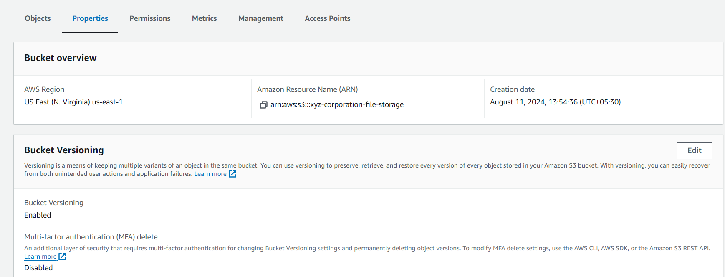

**Step 2: Re-upload Any 2 Files to Verify Versioning**

1. **Re-upload Files**:
   * Go back to the **Objects** tab in your bucket.
   * Click on the **Upload** button.
   * Click on **Add files** and select the two files you want to re-upload (e.g., one .txt file and one .bmp file).
   * Click **Upload**.

**Step 3: Verify Versioning**

1. **View Object Versions**:
   * After uploading, navigate back to the **Objects** tab.
   * Click on the **Show versions** button (you may need to enable this to see versioned objects).

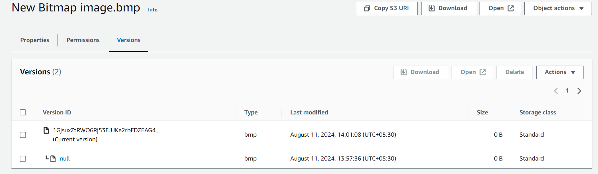

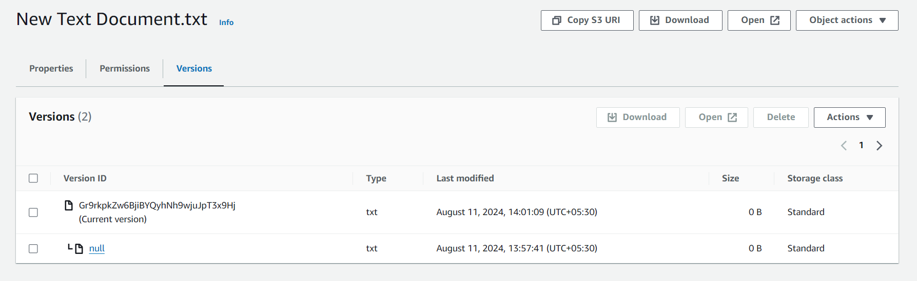

* + You should see both the original files and the new versions listed.